
SNA5000A Series
Vector Network Analyzer
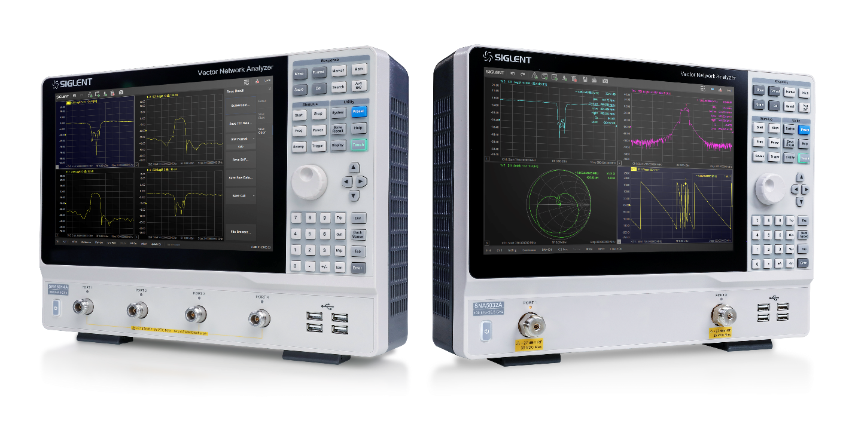
Datasheet
DS09050_E04B

SNA5000A

General Description
The SIGLENT SNA5000A series of Vector Network Analyzers have a frequency range of 9 kHz to 8.5 GHz and 100 kHz to 26.5 GHz, which support 2/4-port scattering parameter, differential-parameter, and time-domain parameter measurements. The SNA5000A series of VNAs are effective instrumentation for determining the Q-factor, bandwidth, and insertion loss of a filter, They feature impedance conversion, movement of measurement plane, limit testing, ripple test, fixture simulation, and adapter removal/insertion adjustments. The VNAs have five sweep types: Linear-Frequency mode, Log-Frequency mode, Power-Sweep mode, CW-Time mode, and Segment-Sweep mode. The SNA5000A series VNAs also support scattering-parameter correction of SOLT, SOLR, TRL, Response, and Enhanced Response for increased flexibility in R&D and manufacturing applications.

Features
- Frequency range: 9 kHz - 8.5 GHz and 100 kHz - 26.5 GHz
- Frequency resolution: 1 Hz
- Level resolution: 0.05 dB
- Range of IFBW: 1 Hz~10 MHz
- Setting range of output level:
-55 dBm ~ +10 dBm
- Dynamic range: 125 dB
- Types of calibration: Response calibration, Enhanced Response calibration, Full-one port calibration, Full-two port calibration, Full-three port calibration, Full-four port calibration, TRL calibration
- Types of measurement: Scattering-parameter measurement, differential-parameter measurement, receiver measurement, time-domain parameter analysis, limit test, ripple test, impedance conversion, fixture simulation, adapter removal/insertion, spectrum analysis frequency offset, scalar mixer measurement, pulse measurement, Material Measurement, Gain Compression measurement, Vector mixer measurement
- Internal Bias-Tee connections
- Interface: LAN, USB Device, USB Host (USB-GPIB)
- Remote control: SCPI/ Labview/ IVI based on USB-TMC / VXI-11 / Socket /Telnet / WebServer
- 12.1-inch touch screen
- Video output: HDMI

Models and key specifications
Model | SNA5002A/ SNA5004A | SNA5012A/ SNA5014A | SNA5022A | SNA5032A
Frequency range | 9kHz-4.5GHz | 9kHz-8.5GHz | 100kHz-13.5GHz | 100kHz-26.5GHz
Ports | 2/4 | 2/4 | 2 | 2
Frequency resolution | 1 Hz
Level resolution | 0.05 dB
Range of IFBW | 1 Hz~10 MHz
Number of points | 2 to 20,001
Setting range of  output level | -55 dBm ~ +10 dBm
Dynamic range | 125 dB
Types of calibration | Response calibration, Enhanced Response calibration, Full-one port  calibration, Full-two port calibration, Full-three port calibration, Full-four port calibration, TRL calibration
Types of  measurement | Scattering-parameter measurement, differential-parameter measurement, receiver measurement, time-domain parameter analysis, limit test, ripple test, impedance conversion, fixture simulation, adapter removal/insertion, enhanced time-domain parameter analysis (TDR), spectrum analysis, frequency offset, scalar mixer measurement, pulse measurement, Material Measurement, Gain Compression measurement, Vector mixer measurement
Bias-Tees | Support
Interface | LAN, USB Device, USB Host(USB-GPIB)
Remote control | SCPI/ Labview/ IVI based on USB-TMC/ VXI-11/ Socket/ Telnet/ WebServer
Display | 12.1-inch touch screen
Video output | HDMI

Design Features
Multi-window display:
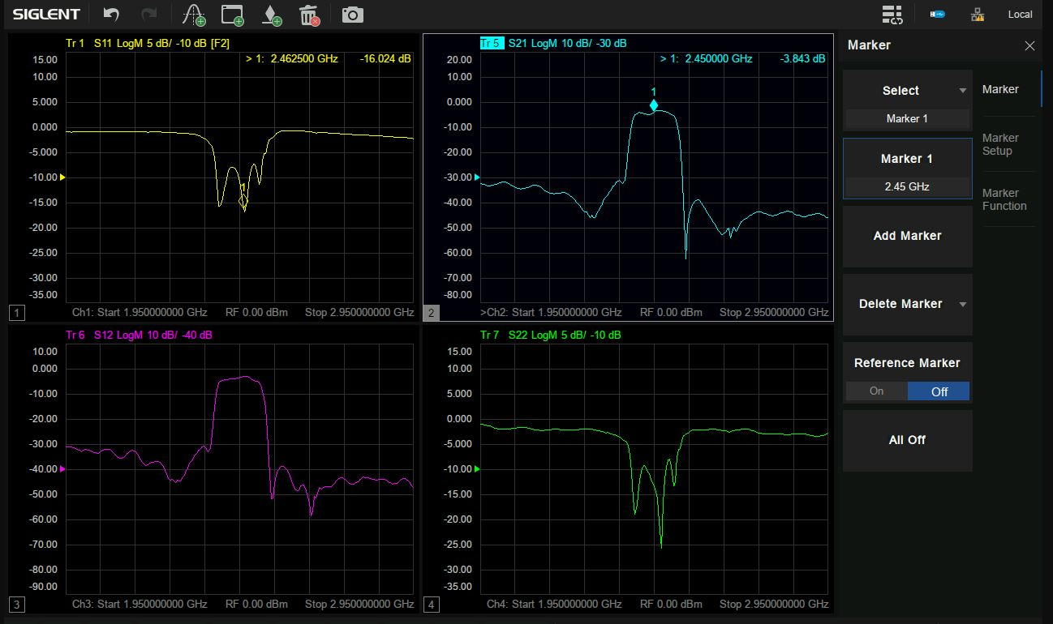

Multi-format display:
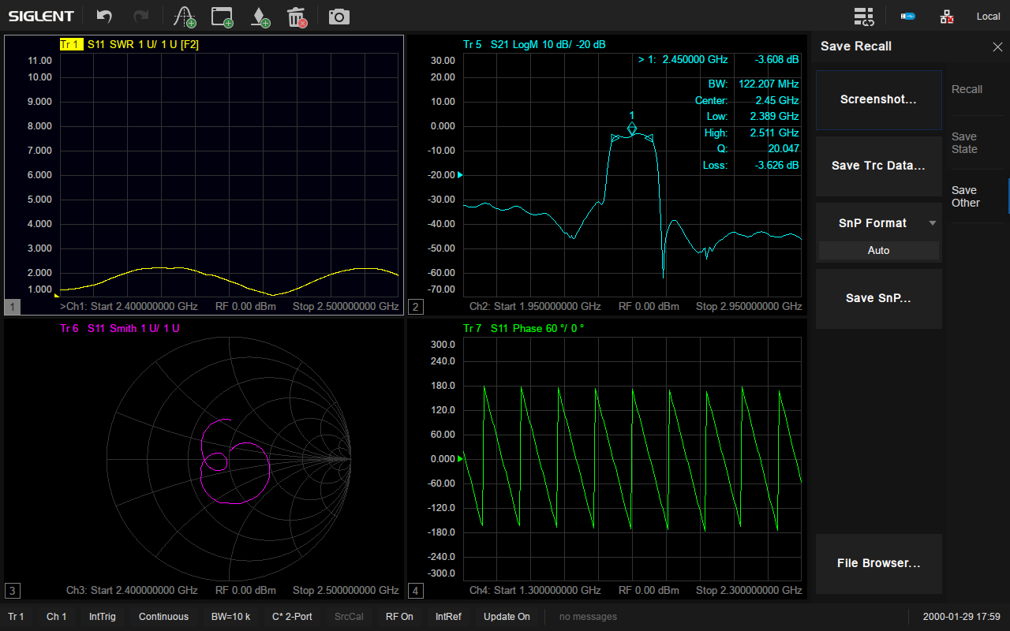

Display and compare memory and current data:
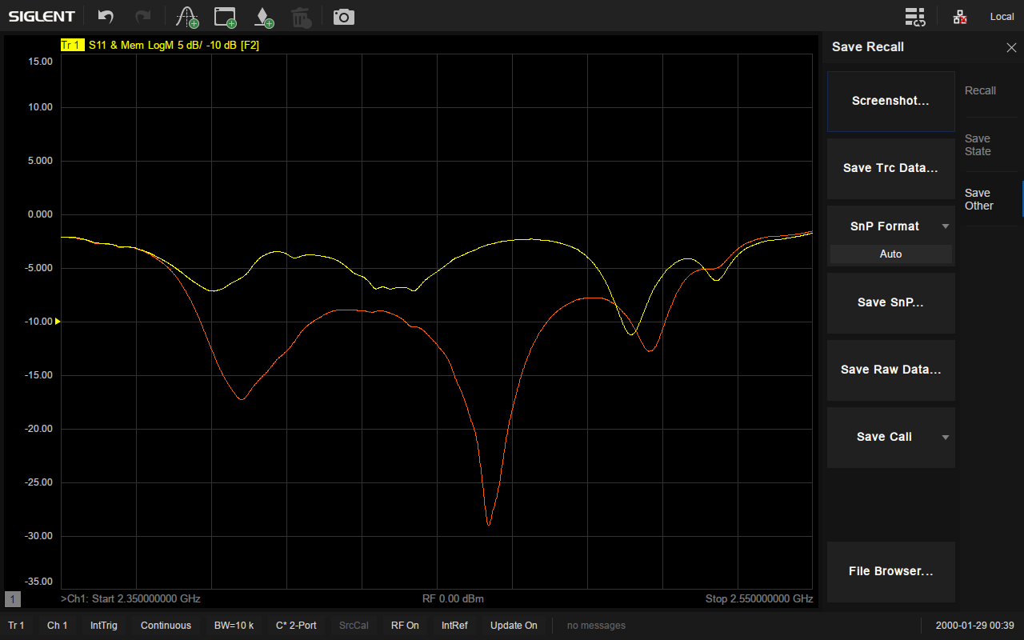

Display data hold:
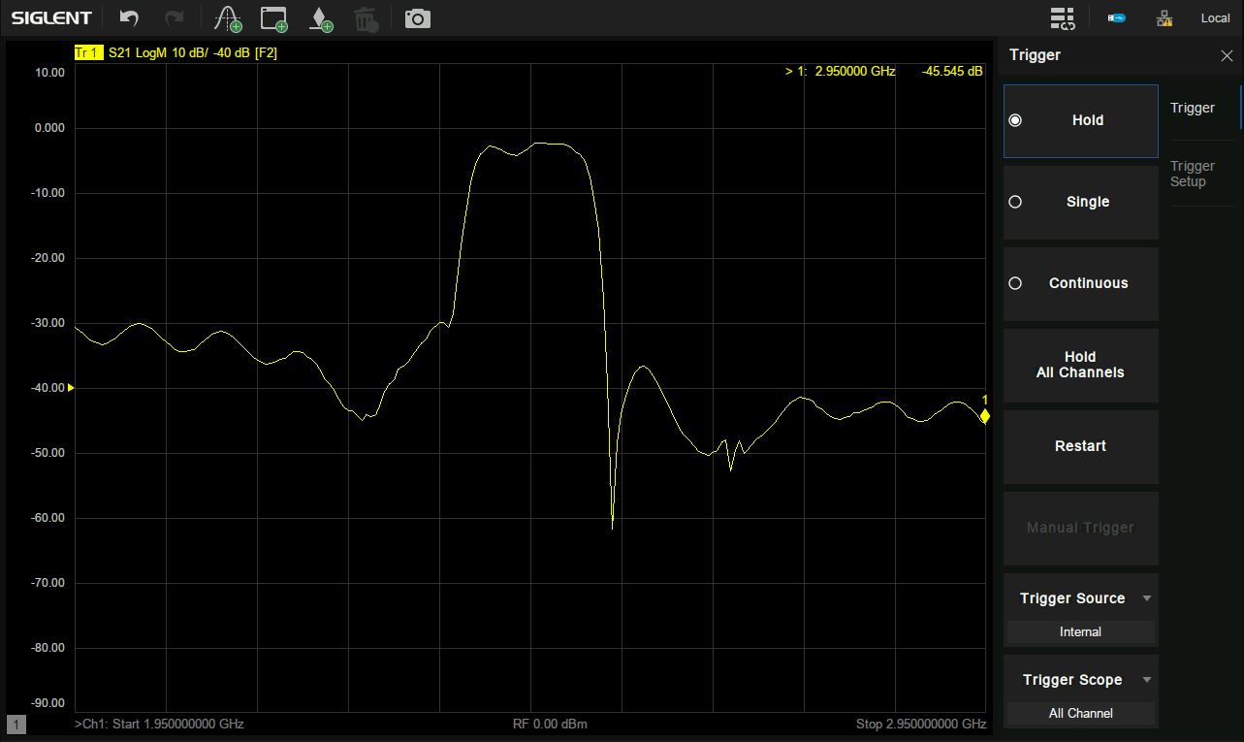

Impedance conversion:
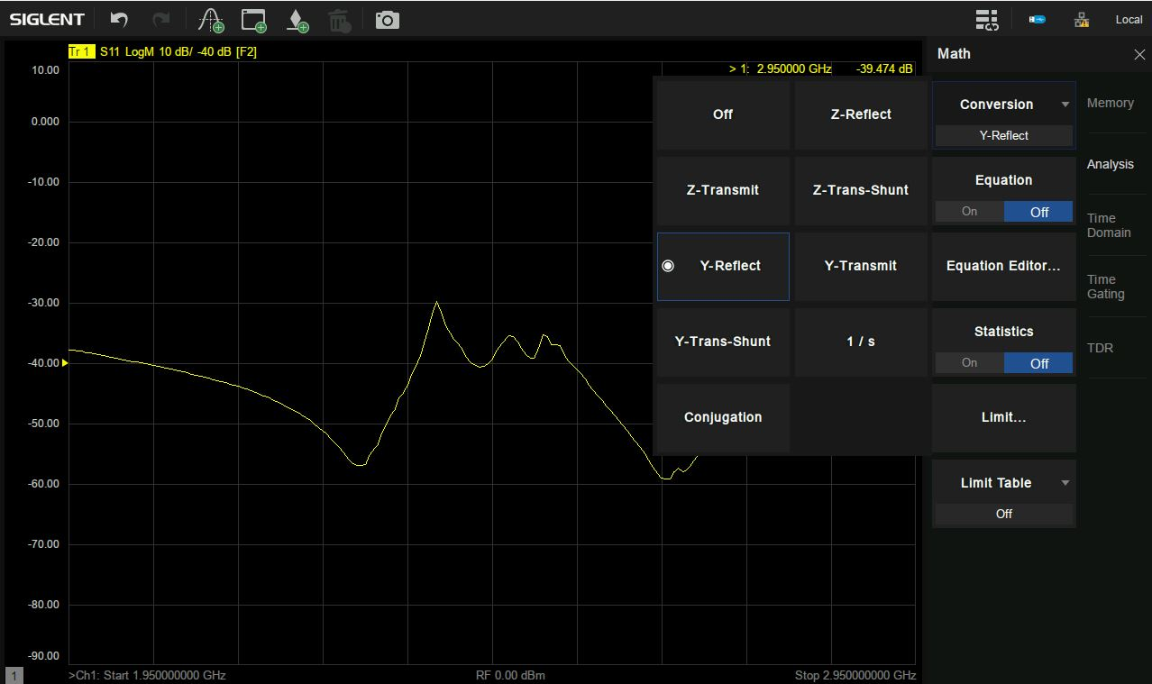

Equation Editor:
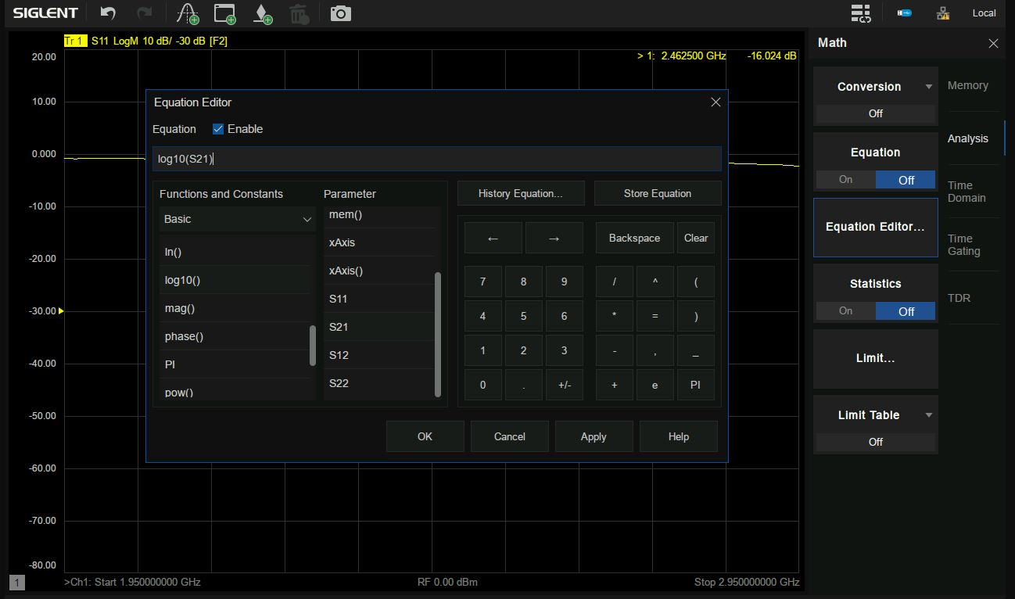

Port Extensions:
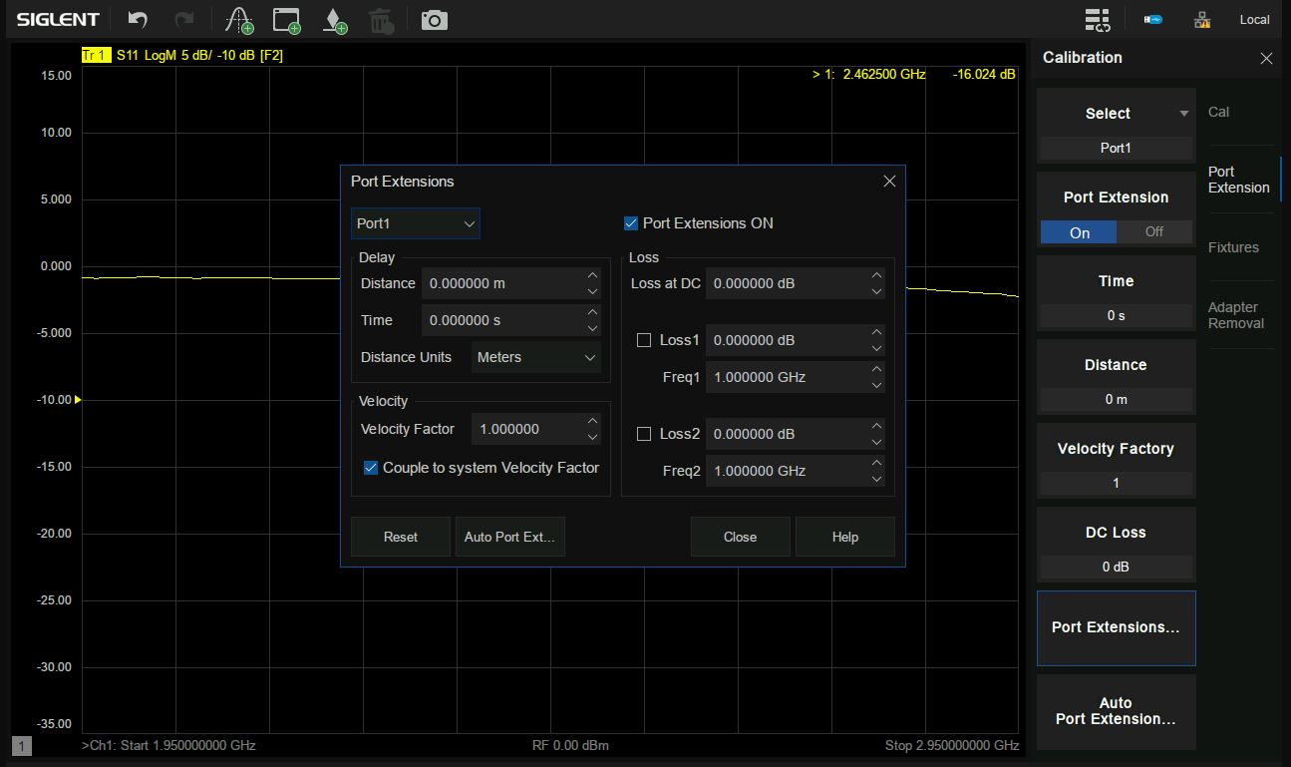

Embedding and De-Embedding:
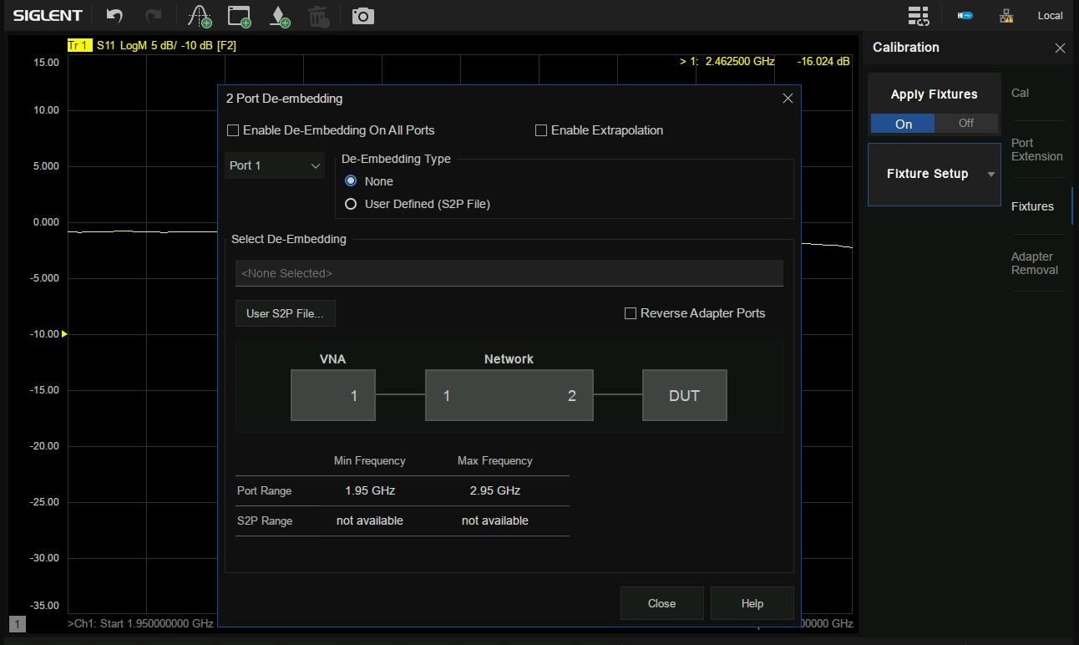

Time-Domain analysis
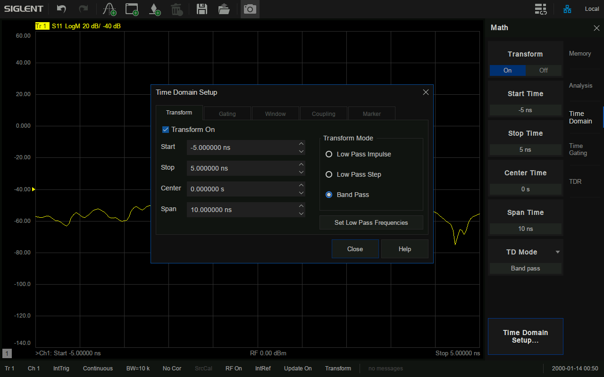

Enhanced Time-Domain analysis(TDR)
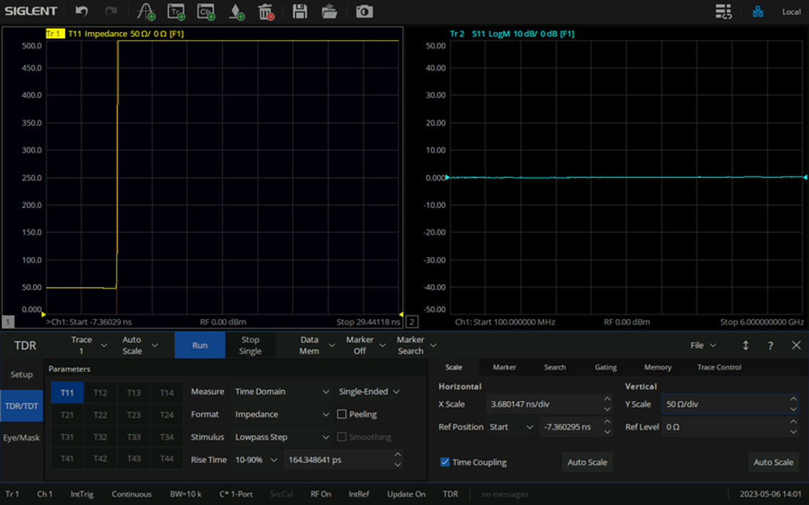

Spectrum analysis
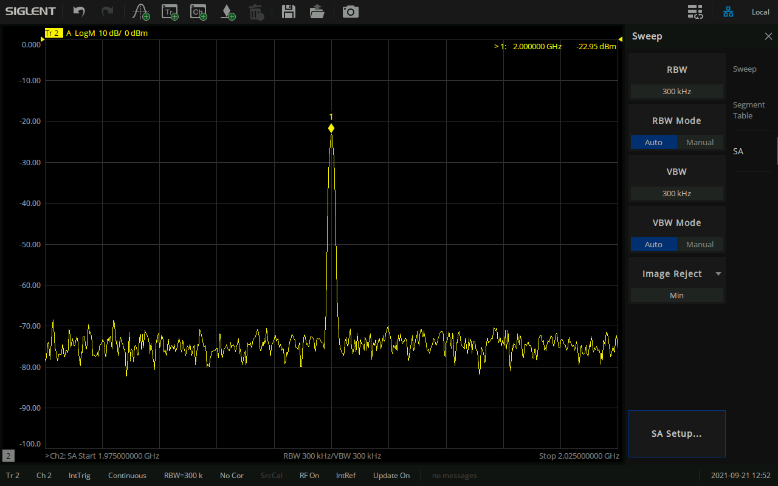

Scalar mixer measurement
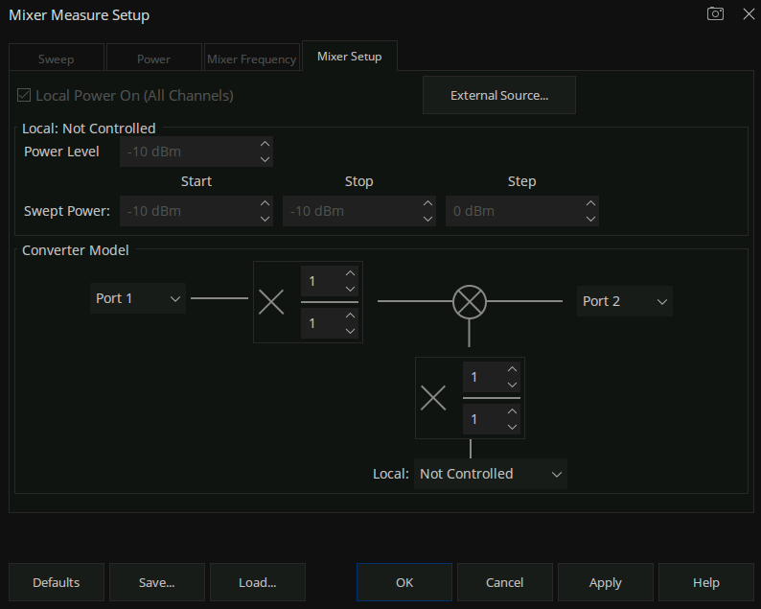

Vector mixer measurement
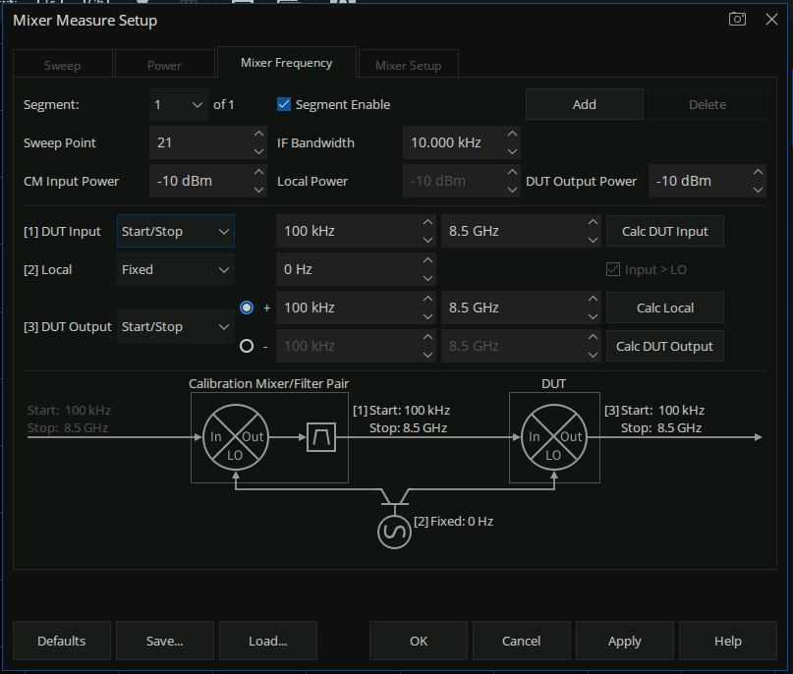
Gain Compression measurement
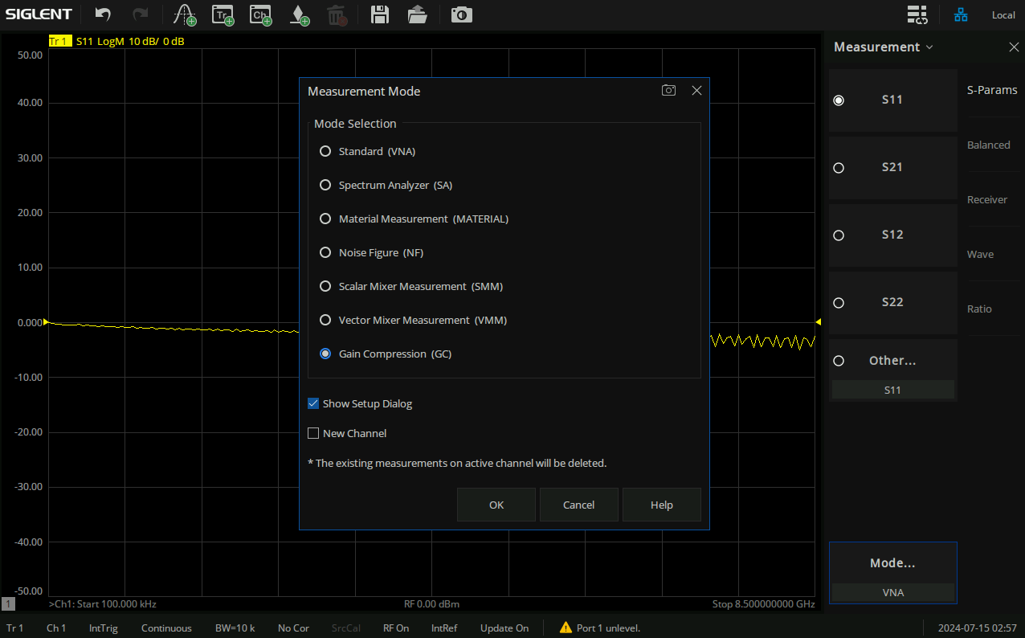

Pulse Modulation
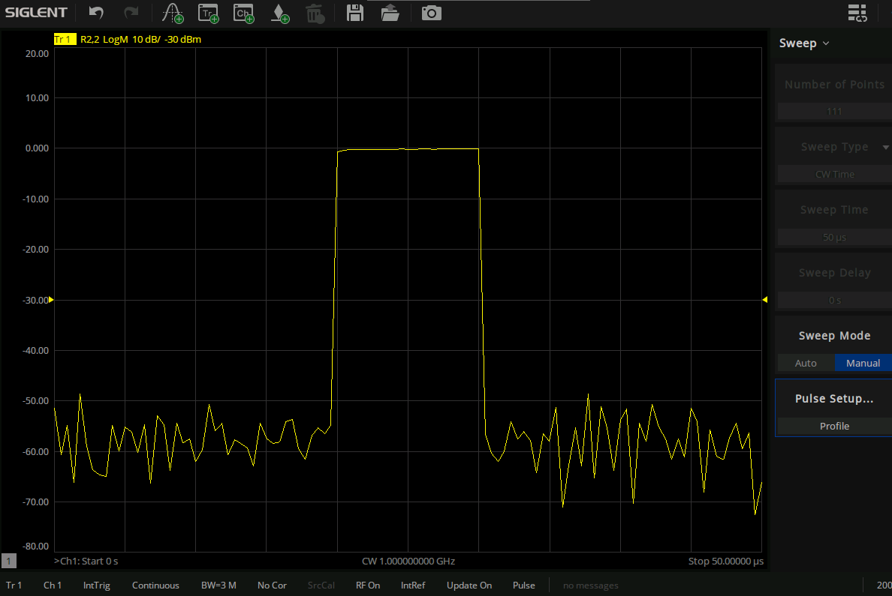
Material Measurement
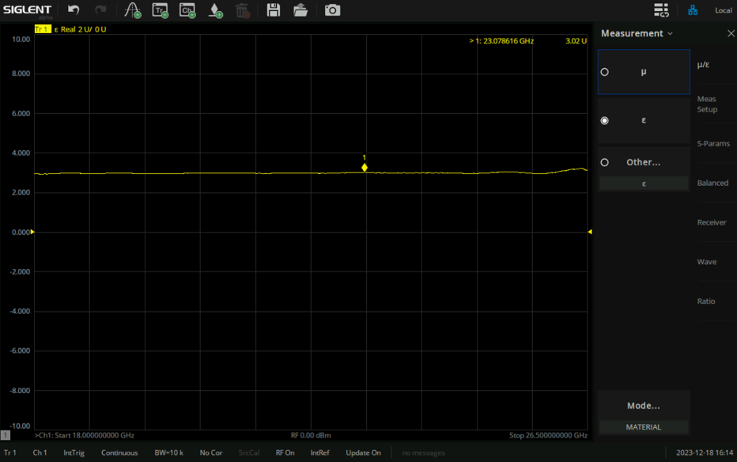

Switch matrix measurement
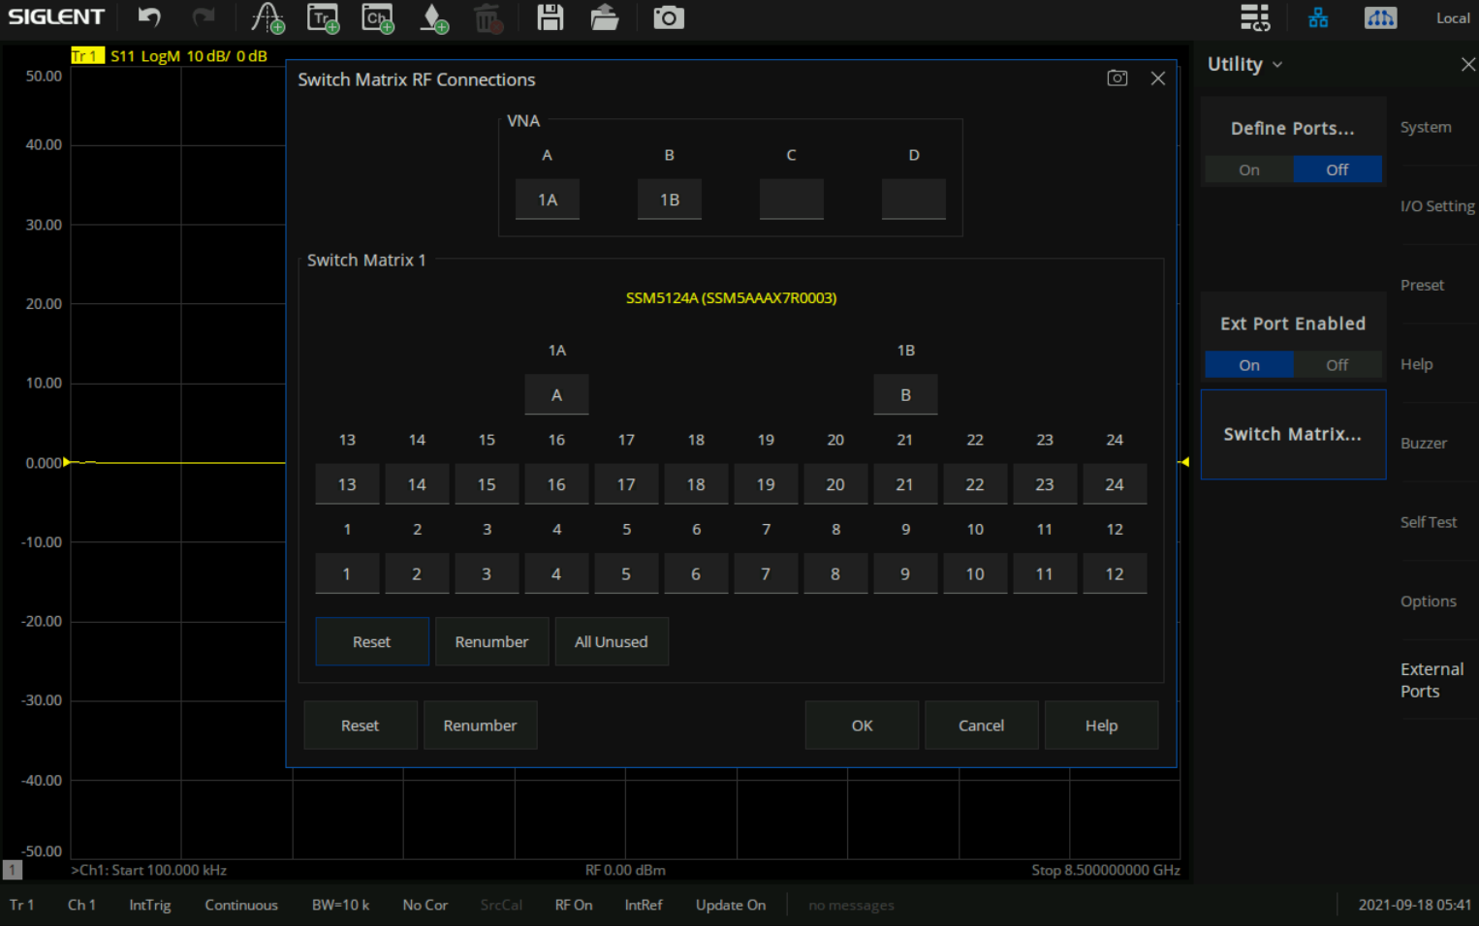

Definitions
Specifications are valid under the following conditions: The instrument is within the calibration period, has been stored between 0 and 40℃ for at least 2 hours before use, and has been powered on and warmed up for at least 90 minutes. The specifications include the measurement uncertainty unless otherwise noted.
Specifications(Spec.): All products are guaranteed to meet published specifications at room temperature (approximately 25℃), unless otherwise noted.
Typical(Typ.): Performance deemed typical implies that 80 percent of the measurement results will meet the typical published performance with a 95th percentile confidence level at room temperature (approximately 25℃). Typical performance is not warranted and does not include measurement uncertainty.
Nominal: This value indicates the expected mean or average performance, or an attribute whose performance is by design, such as the 50 Ohm connector.

Specifications

Dynamic range
SNA5002A/SNA5012A/SNA5004A/SNA5014A
Frequency range | IFBW | Specification(dB) | Typical (dB)
9 kHz-18 kHz | 10Hz | 85 | 102
18 kHz-30 kHz | 10Hz | 90 | 105
30 kHz-100 kHz | 10Hz | 95 | 107
100 kHz-300 kHz | 10Hz | 105 | 117
300 kHz-500 kHz | 10Hz | 120 | 130
500 kHz-1 MHz | 10Hz | 125 | 136
1 MHz-5 GHz | 10Hz | 125 | 140
5 GHz-6.8 GHz | 10Hz | 123 | 133
6.8 GHz-7.7 GHz | 10Hz | 120 | 130
7.7 GHz-8 GHz | 10Hz | 119 | 129
8 GHz -8.5 GHz | 10Hz | 117 | 127
SNA5022A/SNA5032A
Frequency range | IFBW | Specification(dB) | Typical (dB)
100 kHz-10 MHz | 10Hz | 115 | 125
10 MHz-3 GHz | 10Hz | 125 | 135
3 GHz-9 GHz | 10Hz | 125 | 135
9 GHz-13.5 GHz | 10Hz | 118 | 125
13.5 GHz-20 GHz | 10Hz | 115 | 125
20 GHz-26.5 GHz | 10Hz | 110 | 120

Corrected system performance with calibration kit
User correction: On, system correction: On; Corrected system performance with Keysight 85052D 3.5mm calibration kit, isolation calibration performed.IFBW is 10 Hz, no averaging applied to data, and environmental temperature is 25℃ (± 5℃), with < 1℃ deviation from calibration temperature.
SNA5002A/SNA5012A/SNA5004A/SNA5014A
Specification (dB) | 9 kHz-3 GHz | 3 GHz-6 GHz | 6 GHz-8.5 GHz
Directivity | 41 | 39 | 37
Source match | 36 | 30 | 29
Load match | 41 | 37 | 35
Reflect tracking | ±0.004 | ±0.003 | ±0.004
Transmission tracking | ±0.06 | ±0.09 | ±0.11

Reflection uncertainty (Specification, Power: -10 dBm, IFBW:10 Hz):
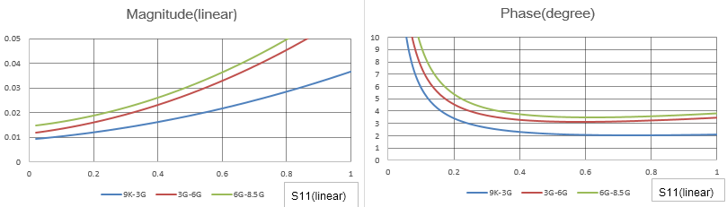

Transmission uncertainty (Specification, Power: -10 dBm, IFBW:10 Hz):
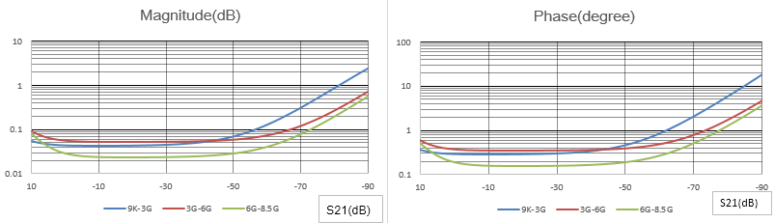
SNA5022A/SNA5032A
Specification (dB) | 100 kHz-9 GHz | 9 GHz-20 GHz | 20 GHz-26.5 GHz
Directivity | 40 | 36 | 35
Source match | 35 | 29 | 27
Load match | 39 | 36 | 33
Reflect tracking | ±0.004 | ±0.003 | ±0.01
Transmission tracking | ±0.06 | ±0.09 | ±0.5
Reflection uncertainty (Specification, Power: -10 dBm, IFBW:10 Hz):
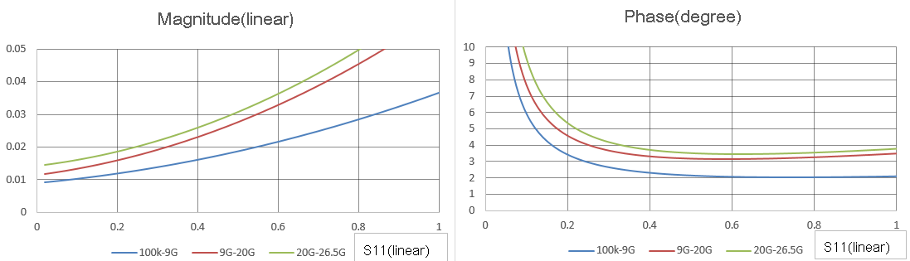
Transmission uncertainty (Specification, Power: -10 dBm, IFBW:10 Hz):
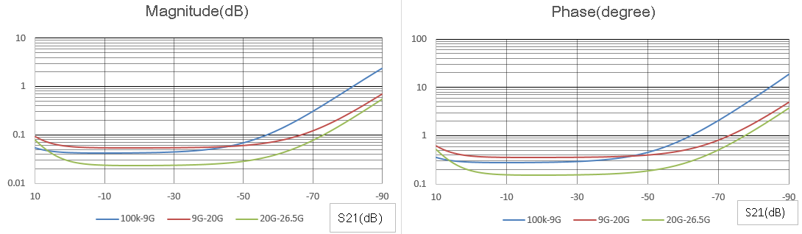

Uncorrected system performance
User correction: Off, system correction: On; IFBW is 10 Hz, no averaging applied to data.
SNA5002A/SNA5012A/SNA5004A/SNA5014A
Specification (dB) | 9 kHz-30 MHz | 30 MHz-3 GHz | 3 GHz-6 GHz | 6 GHz-8.5 GHz
Directivity | 22 | 22 | 20 | 16
Source match | 22 | 22 | 20 | 16
Load match | 6 | 12 | 11 | 10
Reflect tracking | ±1.0 | ±1.0 | ±1.0 | ±1.0
Transmission tracking | ±1.0 | ±1.0 | ±1.0 | ±1.0

SNA5022A/SNA5032A
Specification (dB) | 100 KHz-1 GHz | 1 GHz-9 GHz | 9 GHz-20 GHz | 20 GHz-26.5 GHz
Directivity | 20 | 20 | 16 | 13
Source match | 20 | 20 | 16 | 13
Load match | 8 | 11 | 7 | 7
Reflect tracking | ±1.4 | ±1.4 | ±1.0 | ±1.0
Transmission tracking | ±1.4 | ±1.4 | ±1.0 | ±1.0

Test port output (Source)

Test port output frequency
Description | Specification
Frequency range
SNA5002A，SNA5004A | 9 kHz to 4.5 GHz
SNA5012A，SNA5014A | 9 kHz to 8.5 GHz
SNA5022A | 100 kHz to 13.5 GHz
SNA5032A | 100 kHz to 26.5 GHz
Frequency resolution¹
9 KHz – 3.8 GHz | 1 Hz
3.8 GHz – 7.8 GHz | 2 Hz
7.8 GHz – 13.5 GHz | 4 Hz
13.5 GHz – 26.5 GHz | 8 Hz
CW accuracy
Standard | ± 1.0 ppm (23 ± 3℃ )
Option: SNA5000-HPR | ± 0.1 ppm (23 ± 3℃ )
Source stability
Standard | ± 1.0 ppm (0 to 40℃ )  ± 0.5 ppm/year，± 3.0 ppm/20 year
Option: SNA5000-HPR | ± 1 ppb (0 to 40℃ )  ± 50 ppb/year
¹ Firmware revision V2.13 or later is required.

Test port output power
SNA5002A/SNA5012A/SNA5004A/SNA5014A
Description | Specification | Typical
Preset power | 0 dBm
Level accuracy | ±1.5 dB@0 dBm¹
Level linearity
9 kHz- 18 kHz | ±0.75 dB(-20 dBm to -5 dBm)
18 kHz- 30 kHz | ±0.75 dB(-20 dBm to 0 dBm)
30 kHz- 70 kHz | ±0.75 dB(-20 dBm to 2 dBm)
70 kHz- 100 kHz | ±0.75 dB(-20 dBm to 5 dBm)
100 kHz- 300 kHz | ±0.75 dB(-20 dBm to 7 dBm)
300 kHz- 4.5 GHz | ±0.75 dB(-20 dBm to 10 dBm)
4.5 GHz- 6.8 GHz | ±0.75 dB(-20 dBm to 8 dBm)
6.8 GHz- 7.7 GHz | ±0.75 dB(-20 dBm to 5 dBm)
7.7 GHz- 8 GHz | ±0.75 dB(-20 dBm to 4 dBm)
8 GHz- 8.5 GHz | ±0.75 dB(-20 dBm to 0 dBm)
Range
9 kHz- 18 kHz | -55 dBm to -5dBm
18 kHz- 30 kHz | -55 dBm to 0 dBm
30 kHz- 70 kHz | -55 dBm to 2dBm
70 kHz- 100 kHz | -55 dBm to 5dBm
100 kHz- 300 kHz | -55 dBm to 7dBm
300 kHz- 4.5 GHz | -55 dBm to 10 dBm
4.5 GHz- 6.8 GHz | -55 dBm to 8 dBm
6.8 GHz- 7.7 GHz | -55 dBm to 5 dBm
7.7 GHz- 8 GHz | -55 dBm to 4 dBm
8 GHz- 8.5 GHz | -55 dBm to 0 dBm
Sweep range
9 kHz- 18 kHz | -55 dBm to -5dBm
18 kHz- 30 kHz | -55 dBm to 0 dBm
70 kHz- 100 kHz | -55 dBm to 2dBm
30 kHz- 70 kHz | -55 dBm to 5dBm
100 kHz- 300 kHz | -55 dBm to 7dBm
300 kHz- 4.5 GHz | -55 dBm to 10 dBm
4.5 GHz- 6.8 GHz | -55 dBm to 8 dBm
6.8 GHz- 7.7 GHz | -55 dBm to 5 dBm
7.7 GHz- 8 GHz | -55 dBm to 4 dBm
8 GHz- 8.5 GHz | -55 dBm to 0 dBm
Max leveled power
9 kHz- 18 kHz | -5 dBm | -1 dBm
18 kHz-30 kHz | 0 dBm | 2 dBm
30 kHz- 70 kHz | 2 dBm | 5 dBm
70 kHz-100 kHz | 5 dBm | 7 dBm
100 kHz-300 kHz | 7 dBm | 10 dBm
300 kHz- 4.5 GHz | 10 dBm | 13 dBm
4.5 GHz- 6.8 GHz | 8 dBm | 10 dBm
6.8 GHz-7.7 GHz | 5 dBm | 8 dBm
7.7 GHz- 8 GHz | 4 dBm | 6 dBm
8 GHz- 8.5 GHz | 0 dBm | 4 dBm
Level resolution |  | 0.05 dB
¹ The level accuracy of 9 kHz- 18 kHz is ±1.5dB@-5dBm

SNA5022A/SNA5032A
Description | Specification | Typical
Preset power | 0 dBm
Level accuracy
100 kHz - 10 MHz | ±2.0 dB@0 dBm
10 MHz - 20 GHz | ±1.5 dB@0 dBm
20 GHz- 26.5 GHz | ±2.0 dB@0 dBm
Level linearity
100 kHz- 10 MHz | ±0.75 dB（-20 dBm to 10 dBm）
10 MHz- 3 GHz | ±0.75 dB（-20 dBm to 10 dBm）
3 GHz- 9 GHz | ±0.75 dB（-20 dBm to 10 dBm）
9 GHz- 13.5 GHz | ±1.0 dB（-20 dBm to 5 dBm）
13.5 GHz- 20 GHz | ±1.0 dB（-20 dBm to 5 dBm）
20 GHz- 26.5 GHz | ±1.2 dB（-20 dBm to 0 dBm）
Range
100 kHz- 10 MHz | -55 dBm to 10 dBm
10 MHz- 3 GHz | -55 dBm to 10 dBm
3 GHz- 9 GHz | -55 dBm to 10 dBm
9 GHz- 13.5 GHz | -55 dBm to 5 dBm
13.5 GHz- 20 GHz | -55 dBm to 5 dBm
20 GHz- 26.5 GHz | -55 dBm to 0 dBm
Sweep range
100 kHz- 10 MHz | -55 dBm to 10 dBm
10 MHz- 3 GHz | -55 dBm to 10 dBm
3 GHz- 9 GHz | -55 dBm to 10 dBm
9 GHz- 13.5 GHz | -55 dBm to 5 dBm
13.5 GHz- 20 GHz | -55 dBm to 5 dBm
20 GHz- 26.5 GHz | -55 dBm to 0 dBm
Max leveled power
100 kHz- 10 MHz | 10 dBm | 11 dBm
10 MHz- 3 GHz | 10 dBm | 13 dBm
3 GHz- 9 GHz | 10 dBm | 12 dBm
9 GHz- 13.5 GHz | 5 dBm | 10 dBm
13.5 GHz- 20 GHz | 5 dBm | 10 dBm
20 GHz- 26.5 GHz | 0 dBm | 8 dBm
Power resolution |  | 0.05 dB

Test port output signal purity
Description | Specification | Typical
2nd or 3rd harmonics (0 dBm)
9 kHz to 100 kHz |  | <–15 dBc
100 kHz to 26.5 GHz |  | <–25 dBc
Non-harmonic spurious (0 dBm) |  | <-30 dBc

Test port input

Test port input levels
SNA5002A/SNA5012A/SNA5004A/SNA5014A
Description | Specification | Typical
Max input level
9 kHz-8.5 GHz | +10 dBm
Damage input level
9 kHz-8.5 GHz | +27 dBm (RF) or 35 V (DC)
Crosstalk
9 kHz- 18 kHz | -75 dB | -96 dB
18 kHz-50 kHz | -90 dB | -106 dB
50 kHz-100 kHz | -90 dB | -110 dB
100 kHz-500 kHz | -110 dB | -120 dB
500 kHz- 1 MHz | -115 dB | -130 dB
1 MHz- 5.8 GHz² | -125 dB | -140 dB
5.8 GHz-8.5 GHz | -115 dB | -130 dB
Noise floor
9 kHz- 100 kHz | -100 dBm/Hz | -115 dBm/Hz
100 kHz-300 kHz | -110 dBm/Hz | -125 dBm/Hz
300 kHz-500 kHz | -115 dBm/Hz | -130 dBm/Hz
500 kHz- 1 MHz | -120 dBm/Hz | -136 dBm/Hz
1 MHz- 5 GHz² | -125 dBm/Hz | -140 dBm/Hz
5 GHz-8.5 GHz | -120 dBm/Hz | -135 dBm/Hz
Compression level(+10 dBm)
Magnitude
9 kHz- 100 kHz | 0.3dB | 0.09 dB
100 kHz- 8.5GHz | 0.2dB | 0.08dB
Phase
9 kHz- 100 kHz | 0.5 deg | 0.36 deg
100 kHz- 8.5GHz | 0.5 deg | 0.3 deg
² 467.25MHz and 471.5MHz points do not meet the specs requirement.
SNA5022A/SNA5032A
Description | Specification | Typical
Max input level
100 kHz-26.5 GHz | +10 dBm
Damage input level
100 kHz-26.5 GHz | +27 dBm (RF) or 35 V (DC)
Level accuracy
100 kHz - 10 MHz | ±2.5 dB@0 dBm
10 MHz - 20 GHz | ±1.5 dB@0 dBm
20 GHz- 26.5 GHz | ±2.0 dB@0 dBm
Crosstalk
100 kHz- 10 MHz | -100 dB | -110 dB
10 MHz- 3GHz³ | -125 dB | -140 dB
3 GHz- 13.5 GHz | -120 dB | -125 dB
13.5 GHz- 26.5 GHz | -105 dB | -115 dB
Noise floor
100 kHz- 10 MHz | -110 dBm/Hz | -120 dBm/Hz
10 MHz- 3 GHz³ | -122 dBm/Hz | -132 dBm/Hz
3 GHz- 9 GHz | -125 dBm/Hz | -135 dBm/Hz
9 GHz- 13.5 GHz | -125 dBm/Hz | -135 dBm/Hz
13.5 GHz- 20 GHz | -122 dBm/Hz | -132 dBm/Hz
20 GHz- 26.5 GHz | -118 dBm/Hz | -128 dBm/Hz
Compression level(+10 dBm)
Magnitude
100 kHz- 13.5 GHz | 0.5 dB | 0.3 dB
13.5 GHz- 26.5 GHz | 1.0 dB | 0.5 dB
Phase
100 kHz- 13.5 GHz | 5 deg | 1 deg
13.5 GHz- 26.5 GHz | 5 deg | 1.5 deg
³ 20MHz and 30MHz points do not meet the specs requirement.

Trace noise
SNA5002A/SNA5012A/SNA5004A/SNA5014A
Description | Specification | Typical
Note:Setting max output power
Transmission trace noise magnitude
9 kHz- 50 kHz (IFBW=1 kHz) | 0.005 dB rms | 0.0015 dB rms
50 kHz- 1 MHz (IFBW=1 kHz) | 0.003 dB rms | 0.0015 dB rms
1 MHz- 8 GHz (IFBW=10 kHz) | 0.003 dB rms | 0.0015 dB rms
8 GHz-8.5 GHz(IFBW=10 kHz) | 0.005 dB rms | 0.0025 dB rms
Reflection trace noise magnitude
9 kHz- 50 kHz (IFBW=1 kHz) | 0.005 dB rms | 0.0015 dB rms
50 kHz- 1 MHz (IFBW=1 kHz) | 0.003 dB rms | 0.0010 dB rms
1 MHz- 8 GHz (IFBW=10 kHz) | 0.003 dB rms | 0.0015 dB rms
8 GHz-8.5 GHz(IFBW=10 kHz) | 0.005 dB rms | 0.0020 dB rms
Transmission trace noise phase
9 kHz- 50 kHz (IFBW=1 kHz) | 0.04 deg rms | 0.02 deg rms
50 kHz- 1 MHz (IFBW=1 kHz) | 0.03 deg rms | 0.015 deg rms
1 MHz- 8.5 GHz (IFBW=10 kHz) | 0.05 deg rms | 0.02 deg rms
Reflection trace noise phase
9 kHz- 50 kHz (IFBW=1 kHz) | 0.03 deg rms | 0.015 deg rms
50 kHz- 1 MHz (IFBW=1 kHz) | 0.03 deg rms | 0.015 deg rms
1 MHz- 8.5 GHz (IFBW=10 kHz) | 0.05 deg rms | 0.020 deg rms

SNA5022A/SNA5032A
Description | Specification | Typical
Note:Setting max output power
Transmission trace noise magnitude
100 kHz- 10 MHz (IFBW=1 kHz) | 0.009 dB rms | 0.0015 dB rms
10 MHz- 13.5 GHz (IFBW=10 kHz) | 0.006 dB rms | 0.0015 dB rms
13.5 GHz- 26.5 GHz (IFBW=10 kHz) | 0.015 dB rms | 0.0025 dB rms
Reflection trace noise magnitude
100 kHz- 10 MHz (IFBW=1 kHz) | 0.003 dB rms | 0.0015 dB rms
10 MHz- 13.5 GHz (IFBW=10 kHz) | 0.009 dB rms | 0.0015 dB rms
13.5 GHz- 26.5 GHz (IFBW=10 kHz) | 0.015 dB rms | 0.0025 dB rms
Transmission trace noise phase
100 kHz- 10 MHz (IFBW=1 kHz) | 0.05 deg rms | 0.02 deg rms
10 MHz- 13.5 GHz (IFBW=10 kHz) | 0.05 deg rms | 0.015 deg rms
13.5 GHz- 20 GHz (IFBW=10 kHz) | 0.06 deg rms | 0.02 deg rms
20 GHz- 26.5 GHz (IFBW=10 kHz) | 0.09 deg rms | 0.05 deg rms
Reflection trace noise phase
100 kHz- 10 MHz (IFBW=1 kHz) | 0.03 deg rms | 0.015 deg rms
10 MHz- 13.5 GHz (IFBW=10 kHz) | 0.05 deg rms | 0.015 deg rms
13.5 GHz- 20 GHz (IFBW=10 kHz) | 0.07 deg rms | 0.02 deg rms
20 GHz- 26.5 GHz (IFBW=10 kHz) | 0.09 deg rms | 0.05 deg rms

Stability
SNA5002A/SNA5012A/SNA5004A/SNA5014A
Description | Specification | Typical
Magnitude
9 kHz- 3 GHz |  | ± 0.005 dB/°C
3 GHz- 8.5 GHz |  | ± 0.014 dB/°C
Phase
9 kHz- 3 GHz |  | ± 0.1 deg/°C
3 GHz- 8.5 GHz |  | ± 0.3 deg/°C

SNA5022A/SNA5032A
Description | Specification | Typical
Magnitude
100 kHz- 13.5 GHz |  | ± 0.01 dB/°C
13.5 GHz- 26.5 GHz |  | ± 0.05 dB/°C
Phase
100 kHz- 13.5 GHz |  | ± 0.1 deg/°C
13.5 GHz- 26.5 GHz |  | ± 0.9 deg/°C

Dynamic accuracy
SNA5002A/SNA5012A/SNA5004A/SNA5014A
Description | Specification
Relative to -10 dBm input power
Magnitude
10 dBm | ± 1.9 dB
0 dBm | ± 0.08 dB
-20 dBm | ± 0.12 dB
-30 dBm | ± 0.19 dB
-40 dBm | ± 0.25 dB
-50 dBm | ± 0.36 dB
-60 dBm | ± 0.49 dB
-70 dBm | ± 0.65 dB
-80 dBm | ± 0.95 dB
-90 dBm | ± 1.65 dB
-100 dBm | ± 2.0 dB
Phase
10 dBm | ± 15.6 deg
0 dBm | ± 0.46 deg
-20 dBm | ± 0.62 deg
-30 dBm | ± 1.19 deg
-40 dBm | ± 1.25 deg
-50 dBm | ± 2.36 deg
-60 dBm | ± 2.49 deg
-70 dBm | ± 4.65 deg
-80 dBm | ± 6.95 deg
-90 dBm | ± 8.35 deg
-100 dBm | ± 10.38 deg

SNA5022A/SNA5032A
Description | Specification
Relative to -10 dBm input power
Magnitude
10 dBm | ± 2.29 dB
0 dBm | ± 0.09 dB
-20 dBm | ± 0.13 dB
-30 dBm | ± 0.19 dB
-40 dBm | ± 0.27 dB
-50 dBm | ± 0.39 dB
-60 dBm | ± 0.59 dB
-70 dBm | ± 0.85 dB
-80 dBm | ± 1.95 dB
-90 dBm | ± 2.35 dB
-100 dBm | ± 2.5 dB
Phase
10 dBm | ± 14.5 deg
0 dBm | ± 1.45 deg
-20 dBm | ± 1.85 deg
-30 dBm | ± 3.99 deg
-40 dBm | ± 5.27 deg
-50 dBm | ± 6.39 deg
-60 dBm | ± 8.59 deg
-70 dBm | ± 10.85 deg
-80 dBm | ± 11.95 deg
-90 dBm | ± 12.35 deg
-100 dBm | ± 16.5 deg

Pulsed-RF

Pulse Modulation On/Off Ratio (dB)
SNA5002A/SNA5012A/SNA5004A/SNA5014A
Description | Typical
9 kHz- 4.5 GHz | 80
4.5 GHz- 8.5 GHz | 70
SNA5022A/SNA5032A
Description | Typical
9 kHz- 4.5 GHz | 80
4.5 GHz- 26.5 GHz | 70

Pulse Modulation
Description | Typical
Minimum pulse width | 10 usec
Minimum pulse period | 30 usec
Maximum pulse period | 26 sec
Pulse Modulation Shape Example

Sweep time
SNA5002A/SNA5012A/SNA5004A/SNA5014A
Start frequency: 100 kHz, Stop frequency: 8.5 GHz; IFBW: 500 kHz.
Points | 201 | 401 | 1601 | 6401
Uncorrected | 15 ms | 17 ms | 35 ms | 141 ms
2-port cal | 30 ms | 34 ms | 70 ms | 282 ms
4-port cal(8.5GHz) | 60 ms | 68 ms | 140 ms | 564 ms
Start frequency: 100 kHz, Stop frequency: 8.5 GHz; IFBW: 100 kHz.
Points | 201 | 401 | 1601 | 6401
Uncorrected | 17 ms | 20 ms | 46 ms | 185 ms
2-port cal | 34 ms | 40 ms | 92 ms | 370 ms
4-port cal(8.5GHz) | 68 ms | 80 ms | 184 ms | 740 ms
Start frequency: 100 kHz, Stop frequency: 8.5 GHz; IFBW: 10 kHz.
Points | 201 | 401 | 1601 | 6401
Uncorrected | 33 ms | 52 ms | 175 ms | 698 ms
2-port cal | 66 ms | 104 ms | 350 ms | 1396 ms
4-port cal(8.5GHz) | 132 ms | 208 ms | 700 ms | 2792 ms
Start frequency: 100 kHz, Stop frequency: 8.5 GHz; IFBW: 1 kHz.
Points | 201 | 401 | 1601 | 6401
Uncorrected | 193 ms | 372 ms | 1452 ms | 5806 ms
2-port cal | 386 ms | 744 ms | 2904 ms | 11612 ms
4-port cal(8.5GHz) | 772 ms | 1488 ms | 5808 ms | 23224 ms

SNA5022A/SNA5032A
Start frequency: 100 kHz, Stop frequency: 26.5GHz; IFBW: 500 kHz.
Points | 201 | 401 | 1601 | 6401
Uncorrected | 30 ms | 54 ms | 70 ms | 229 ms
2-port cal | 60 ms | 108 ms | 140 ms | 458 ms
Start frequency: 100 kHz, Stop frequency: 26.5GHz; IFBW: 100 kHz.
Points | 201 | 401 | 1601 | 6401
Uncorrected | 31 ms | 57 ms | 82 ms | 275 ms
2-port cal | 62 ms | 114 ms | 164 ms | 550 ms
Start frequency: 100 kHz, Stop frequency: 26.5GHz; IFBW: 10 kHz.
Points | 201 | 401 | 1601 | 6401
Uncorrected | 47 ms | 89 ms | 209 ms | 784 ms
2-port cal | 94 ms | 178 ms | 418 ms | 1568 ms
Start frequency: 100 kHz, Stop frequency: 26.5GHz; IFBW: 1 kHz.
Points | 201 | 401 | 1601 | 6401
Uncorrected | 208 ms | 409 ms | 1487 ms | 5895 ms
2-port cal | 416 ms | 818 ms | 2974 ms | 11790 ms

Enhanced Time Domain Analysis with TDR (SNA5000-TDR)
Description | SNA5002/4A | SNA5012/4A | SNA5022A | SNA5032A
Bandwidth | 4.5 GHz | 8.5 GHz | 13.5 GHz | 26.5 GHz
Input Impedance | 50 Ohm
DC damage Level  at test port | 35 V
Maximum test port input  voltage (Hot TDR Mode) | 1.5Vpp
TDR stimulus | Step, Impulse
TDR step amplitude | 1 mV to 5 V
TDR step rise time  (min) (10% to 90%) | 99.1 ps | 52.5 ps | 33.1 ps | 16.9 ps
TDR step response  resolution in free space  (min) (εr = 1) | 14.9 mm | 7.9 mm | 5 mm | 2.5 mm
TDR impulse width (min) | 134.1 ps | 71.0 ps | 44.7 ps | 22.8 ps
DUT length (max) | 13.8 μs |  | 1.25 μs
Eye diagram data rate (max) | 3.6 Gb/s | 6.8 Gb/s | 10.8 Gb/s | 21.2 Gb/s

General information
Description | Characteristics
Operating environment
Temperature | 0 to 40 ℃
Humidity | Type tested at 20 to 80%, wet bulb temperature < 29 °C (non-condensing)
Altitude | 0 to 3000 m
Non-operating storage environment
Temperature | -20 ℃ to 60 ℃
Humidity | Type tested at 20 to 90%, wet bulb temperature < 40 °C (non-condensing)
Altitude | 0 to 15000 m
Size | W×H×D=378×284×126 mm
Weight | 2-port: 5.5 kg;  4-port or SNA5032A/SNA5022A: 7.5 kg
EMC
Conducted disturbance: CISPR 11/EN 55011 | CLASS A group 1, 150 kHz - 30 MHz
Radiated disturbance: CISPR 11/EN 55011 | CLASS A group 1, 30 MHz -1 GHz
Electrostatic discharge(ESD):  IEC61000-4-2/EN61000-4-2 | 4.0 kV (contact), 8.0 kV (air)
Radio-frequency electromagnetic field Immunity:  IEC 61000-4-3/EN 61000-4-3 | 10 V/m (80 MHz to 1 GHz);  3 V/m (1.4 GHz to 2 GHz);  1 V/m (2.0 GHz to 2.7 GHz)
Electrical fast transients (EFT):  IEC 61000-4-4/EN 61000-4-4 | 2 kV (AC power ports)
Surges: IEC 61000-4-5/EN 61000-4-5 | 1 kV (Line to line) ; 2 kV (Line to ground)
Radio-frequency continuous conducted  Immunity: IEC 61000-4-6/EN 61000-4-6 | 3 V, 0.15-80 MHz
Voltage dips and interruptions:  IEC 61000-4-11/EN 61000-4-11 | Voltage dips:  0% UT during 1 cycle;  40% UT during 10/12 cycles;  70% UT during 25/30 cycles;  Voltage interruptions: 0% UT during 250 cycles
Safety
UL 61010-1:2012/R: 2018-11; CAN/CSA-C22.2 No. 61010-1:2012/A1:2018-11.
UL 61010-2-030:2018; CAN/CSA-C22.2 No. 61010-2-030:2018.

Front panel information
Description | Characteristics
RF connectors | Type-N, female, 50Ω (SNA5002A/SNA5012A/SNA5004A/SNA5014A)  3.5mm NMD（male），50Ω (SNA5032A/SNA5022A)
Damage level | +27 dBm or ±35 VDC
Display Resolution | 12.1 inch TFT color LCD with touch screen ; WXGA (1280 x 800)
USB interface | USB-A 2.0

Rear panel information
Description | Characteristics
Ext trigger input connector
Type | BNC, female
Input level | 5V TTL
Ext trigger output connector
Type | BNC, female
Max output current | 20 mA
Output level | 3.3V TTL
Ext ref-signal input connector
Type | BNC, female
Input frequency | 10 MHz ±10 ppm
Input level | -3 dBm to +10 dBm
Input impedance | 50Ω
Int ref-signal output connector
Type | BNC, female
Output frequency | 10 MHz ± 5 ppm
Signal type | Sinewave
Output level | 0 dBm ± 3 dB into 50 Ω
Output impedance | 50 Ω
Bias tee input connector
Type | BNC, female
Max voltage | ± 35 VDC
Max current (no degradation RF specification) | ± 300 mA
Max current (damage level) | 500 mA
Video output | HDMI
USB (USBTMC) interface | USB-B 2.0
LAN | 10/100 BaseT Ethernet
Power | 100~240 Vrms 50/60 Hz  100~120 Vrms 400 Hz
Power consumption | 2-port: 50 W (typical), 4-port: 70 W (typical)  SNA5032A/SNA5022A: 85 W (typical)

Ordering Information
Items | Description | Order number
Products | 2 ports, 4.5G Vector Network Analyzer | SNA5002A
Products | 2 ports, 8.5G Vector Network Analyzer | SNA5012A
Products | 4 ports, 4.5G Vector Network Analyzer | SNA5004A
Products | 4 ports, 8.5G Vector Network Analyzer | SNA5014A
Products | 2 ports, 13.5G Vector Network Analyzer | SNA5022A
Products | 2 ports, 26.5G Vector Network Analyzer | SNA5032A
Standard Accessories | 1 x Quick-start, 1 x Power-cable, 1 x USB-cable, 1 x calibration-certificate,  1 x Wireless mouse, 1 x Protective Cover
Optional Accessories | High-performance reference source | SNA5000-HPR
Optional Accessories | Time-Domain analysis | SNA5000-TDA
Optional Accessories | Enhanced Time-Domain analysis | SNA5000-TDR
Optional Accessories | Spectrum analysis | SNA5000-SA
Optional Accessories | Scalar mixer measurement | SNA5000-SMM
Optional Accessories | Performance Tests | SNA5000-PV
Optional Accessories | Pulse measurement | SNA5000-PM
Optional Accessories | Material Measurement | SNA5000-MT
Optional Accessories | Gain Compression measurement | SNA5000-GC
Optional Accessories | Vector mixer measurement | SNA5000-VMM
Optional Accessories | SEM5000A series electronic calibrators | SEM5000A
Optional Accessories | N-type, Male, 50Ω Calibration Kit, 0-4.5GHz | F503ME
Optional Accessories | N-type, Female, 50Ω Calibration Kit, 0-4.5GHz | F503FE
Optional Accessories | N-type, Male, 50Ω Calibration Kit, 0-9GHz | F504MS
Optional Accessories | N-type, Female, 50Ω Calibration Kit, 0-9GHz | F504FS
Optional Accessories | N-type, Male, 50Ω Calibration Kit, 0-9GHz | Y504MS
Optional Accessories | N-type, Female, 50Ω Calibration Kit, 0-9GHz | Y504FS
Optional Accessories | N-type, Male and Female, 50Ω Calibration Kit,0-9GHz | F504TS
Optional Accessories | N-type, Male and Female, 50Ω Calibration Kit,0-18GHz | F505TS
Optional Accessories | 3.5 mm, Male, 50Ω Calibration Kit, 0-4.5GHz | F603ME
Optional Accessories | 3.5 mm, Female, 50Ω Calibration Kit, 0-4.5GHz | F603FE
Optional Accessories | 3.5 mm, Male, 50Ω Calibration Kit, 0-9GH | F604MS
Optional Accessories | 3.5 mm, Female, 50Ω Calibration Kit, 0-9GHz | F604FS
Optional Accessories | 3.5 mm, Male and Female, 50Ω Calibration Kit, 0-9GHz | F604TS
Optional Accessories | 3.5 mm, Male, 50Ω Calibration Kit, 0-26.5GHz | Y606MS
Optional Accessories | 3.5 mm, Female, 50Ω Calibration Kit, 0-26.5GHz | Y606FS
Optional Accessories | 3.5 mm, Female, 50Ω Calibration Kit, 0-26.5GHz | F606FS
Optional Accessories | 3.5 mm, Male and Female, 50Ω Calibration Kit, 0-26.5GHz | F606TS
Optional Accessories | 50Ω Waveguide calibration kit, 18-26.5GHz | KWR42A
Optional Accessories | N(M)-SMA(F) RF Cable DC~6 GHz,1000 mm | S06-NMSF-1M
Optional Accessories | N(M)-SMA(F) RF Cable DC~18 GHz,1000 mm | S18-NMSF-1M
Optional Accessories | 2.9 mm(M)- 2.9 mm (F) RF Cable DC~40 GHz,1000 mm | S40-29M29F-1M
Optional Accessories | N(M)-SMA(M) RF Cable DC~18 GHz,1000 mm | N-SMA-18L
Optional Accessories | N(M)-N(M) RF Cable DC~18 GHz,1000 mm | N-N-18L
Optional Accessories | SMA(M)-SMA(M) RF Cable DC~18 GHz,1000 mm | SMA-SMA-18L
Optional Accessories | SMA(M)-SMA(M) RF Cable DC~26.5 GHz,1000 mm | SMA-SMA-26L
Optional Accessories | SMA(F)-SMA(M) RF Cable DC~26.5 GHz,1000 mm | SMAF-SMA-26L
Optional Accessories | NMD 3.5 female-NMD 3.5 Male DC-26.5 GHz,635 mm | V26-N35MN35F-25IN
Optional Accessories | NMD 3.5 female-APC 3.5 female DC-26.5 GHz,635 mm | V26-N35FA35F-25IN
Optional Accessories | USB-GPIB Adapter | USB-GPIB
Optional Accessories | RF demonstration board | SNA-TB01
Optional Accessories | Adjustable Differential TDR probe DC-18 GHz | ADP-18
Optional Accessories | Adjustable Differential TDR probe DC-26.5 GHz | ADP-26
Optional Accessories | Adjustable Single-end TDR probe DC-18 GHz | ASP-18
Optional Accessories | Adjustable Single-end TDR probe DC-26.5 GHz | ASP-26


About SIGLENT
SIGLENT is an international high-tech company, concentrating on R&D, sales, production and services of electronic test & measurement instruments.

SIGLENT first began developing digital oscilloscopes independently in 2002. After more than a decade of continuous development, SIGLENT has extended its product line to include digital oscilloscopes, isolated handheld oscilloscopes, function/arbitrary waveform generators, RF/MW signal generators, spectrum analyzers, vector network analyzers, digital multimeters, DC power supplies, electronic loads and other general purpose test instrumentation. Since its first oscilloscope was launched in 2005, SIGLENT has become the fastest growing manufacturer of digital oscilloscopes. We firmly believe that today SIGLENT is the best value in electronic test & measurement.
Headquarters:
SIGLENT Technologies Co., Ltd
Add: Bldg No.4 & No.5, Antongda Industrial Zone, 3rd Liuxian Road, Bao'an District, Shenzhen, 518101, China
Tel: + 86 755 3688 7876
Fax: + 86 755 3359 1582
Email: sales@siglent.com
Website: int.siglent.com

North America:
SIGLENT Technologies America, Inc
6557 Cochran Rd Solon, Ohio 44139
Tel: 440-398-5800
Toll Free: 877-515-5551
Fax: 440-399-1211
Email: info@siglentna.com
Website: www.siglentna.com

Europe:
SIGLENT Technologies Germany GmbH
Add: Staetzlinger Str. 70
86165 Augsburg, Germany
Tel: +49(0)-821-666 0 111 0
Fax: +49(0)-821-666 0 111 22
Email: info-eu@siglent.com
Website: www.siglenteu.com

